Check & Connect Data Instruction Manual

Table of Contents
Introduction 2
Check & Connect Mentor Weekly Notes Instructions 3
Overview 3
Before You Begin 3
Accessing the Template 3
Check & Connect Mentor Weekly Notes Spreadsheet Contents 4
Setting Up the Mentor Weekly Notes Spreadsheet 5
Filling Out the Reporting Period Tabs 6
Check & Connect Reporting Form Instructions 14
Overview 14
Filling Out the Check & Connect Reporting Form 14
Submitting the Check & Connect Reporting Form 18
Glossary 19
FAQ 21

Last Updated: Aug. 8, 2025 | FOR SUPER COPY EDITORS - 2025-08-07

Introduction
This manual provides step-by-step guidance on Utah’s K-12 Check & Connect data collection process. It defines key data categories and outlines how to collect and use student Attendance, Behavior, and Course Performance (ABC) data. By understanding and leveraging this data, mentors can more effectively support student engagement and academic success on the path to high school graduation.

While mentors are expected to collect a broad range of data to guide their work with students, only a small, targeted subset is reported to the state through the Check & Connect Reporting Form. This selective reporting approach protects student privacy and ensures alignment with state data-sharing policies.

For questions or additional support, please contact Amanda Charlesworth, USBE YIC Check & Connect Program Specialist.

Check & Connect Mentor Weekly Notes Instructions

Overview
Mentors should use this template to track weekly data for each student. Each student on the mentor’s caseload should have their own Weekly Notes file, which is used for the entire school year.

Note: Data entered into the Check & Connect Mentor Weekly Notes spreadsheet will automatically be summarized on the Summary tab. Mentors should use the information on this tab to complete the Check & Connect Reporting Form (via Google Forms) for each student at the end of each reporting period.

Important Dates
- Reporting Period 1: Start of the academic year through October 31.
- Reporting Period 2: November 1 through January 31.
- Reporting Period 3: February 1 through the end of the academic year.

Before You Begin
- Enter data into blank cells only.
- Do NOT add or delete columns or rows, or edit any column or row headings.
- Data entered on the reporting period tabs will be automatically summarized on the “Summary” tab in the workbook.

Accessing the Template
- Open the Check & Connect Mentor Weekly Notes template shared by USBE via Google Sheets.
- If your district does NOT permit Google:
  - Download the file as an Excel spreadsheet and save a master copy of the sheet in a secure location on your computer.
  - Create and save a copy for each student on your caseload.
- If your district permits Google:
  - Make sure you are logged in to Google using your district email address, and NOT a personal Gmail account.
  - Go to File → Make a Copy.
  - Create a copy for each student on your caseload.
  - Name the file based on the student’s first name, last name, and academic year (for example: Amanda_Charlesworth_2025-26).

Check & Connect Mentor Weekly Notes Spreadsheet Contents
- Student Details Tab: Use this tab to enter key background information for each student. This information is required when submitting data to USBE.
- Period 1 Tab: Track weekly student data for Period 1 (start of the academic year through October 31). Data from this tab feeds into the Period 1 section of the Summary tab.
- Period 2 Tab: Track weekly student data for Period 2 (November 1 through January 31). Data from this tab feeds into the Period 2 section of the Summary tab.
- Period 3 Tab: Track weekly student data for Period 3 (February 1 through the end of the academic year). Data from this tab feeds into the Period 3 section of the Summary tab.
- Class Tracker Tab: Use this tab to track the student’s current course load, grades, attendance, and behavior incidents for each class. This tab is for your reference only and is not reported to USBE.
- Attendance Calculator Tab: If attendance data is unavailable through the LEA’s Student Information System (SIS), use this tab to calculate the student’s attendance percentage. Enter values into the white cells, and the tool will automatically calculate the attendance percentage to support consistent reporting.
- Summary Tab: This tab compiles data from each reporting period to provide a comprehensive view of student progress and engagement. You will use this tab to complete the Check & Connect Reporting Form submitted to USBE.

Setting Up the Mentor Weekly Notes Spreadsheet
Fill in the following fields at the beginning of the academic year or when a new student is added to your caseload:

- Mentor Name: Enter your first and last name.
- School Year: Select the current academic year from the drop-down.
- Student Name: Enter the student’s first and last name.
- District: Select your school district from the drop-down.
- State Student ID Number (SSID): Enter the student’s State ID Number.
- District ID Number: Enter the student’s district-specific ID.
- School: Enter the full name of the school the student attends (for example: “Cyprus High School,” NOT “Cyprus”).
- Grade: Select the student’s current grade from the drop-down.
- Individual Education Plan (IEP): Select “Yes” if the student has an IEP to receive special education services. Otherwise, select “No.”
- Section 504 Plan: Select “Yes” if the student has a Section 504 Plan. Otherwise, select “No.”
- Date of Check & Connect Entry: Enter the date the student began the Check & Connect Mentoring Program in MM/DD/YYYY format.
- Youth-in-Care or Prevention: Select whether the student is receiving Check & Connect as a part of Youth-In-Care or Prevention.
- Department of Health and Human Services (DHHS) Provider: Select the student’s DHHS provider from the drop-down.
  - Select “Youth in Care (YIC) Receiving Services” for students who are receiving mentor services but are not in custody of the Division of Child & Family Services (DCFS), the Division of Juvenile Justice & Youth Services (DJJYS), or the Bureau of Indian Affairs (BOIA).
  - Select “Prevention or Postvention” for all non-YIC students receiving mentoring services.
- Service Provider: Enter the student’s service provider. This information can also be found on the Youth in Care – Student Information Form under Placement Information. More than one provider can be listed in the cell.
  - This will inform mentors of the outside agency or agencies they should collaborate with for each student.

Fill in the following fields at the end of the academic year or when a student exits from your caseload:

- Date of Check & Connect Exit: Enter the date the student exited the Check & Connect Mentoring Program in MM/DD/YYYY format.
- Reason for Check & Connect Exit: Select an exit reason from the drop-down.
  - If none of the listed exit reasons apply, please contact Amanda Charlesworth, USBE YIC Check & Connect Program Specialist.

Filling Out the Reporting Period Tabs
START of Reporting Period Data Entry

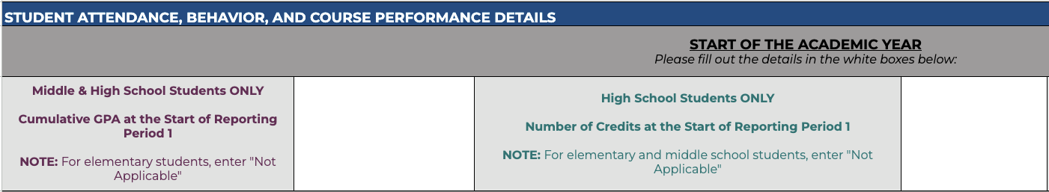

Fill in the following fields at the start of each reporting period:

- Reporting Period 1 begins on the first day of the academic year.
- Reporting Period 2 begins on November 1.
- Reporting Period 3 begins on February 1.

Note: The following fields are specific to a student’s grade level. Be sure to follow the guidance provided below.

- Cumulative GPA at the Start of the Reporting Period: For middle and high school students, enter the student’s cumulative GPA at the start of the reporting period, rounded to two decimal places (for example: 3.10, NOT 3.1).
  - For elementary or middle school students attending a school where GPA is not collected, enter “Not Applicable.”
- Number of Credits at the Start of the Reporting Period: For high school students, enter the total number of credits the student has earned to date, rounded to one decimal place (for example: 3.6, NOT 4).
  - For elementary and middle school students, enter “Not Applicable.”

Weekly Data Entry

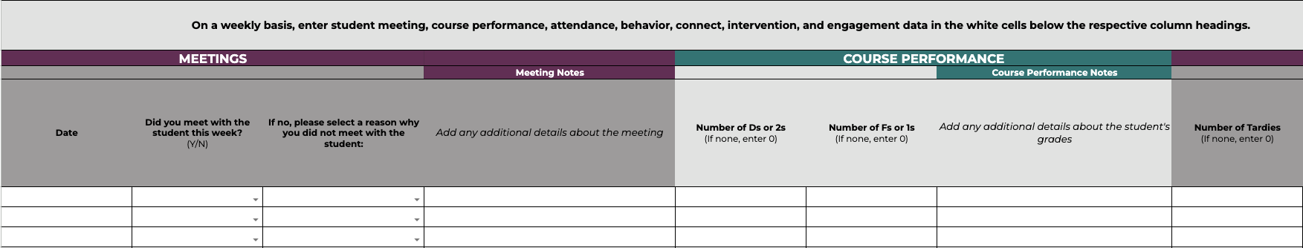

Fill in the following fields weekly:

Meetings
- Date: Enter the date you met with the student in MM/DD/YYYY format. If you did not meet with the student, enter the date you are completing the weekly data.
- Did you meet with the student this week? Select “Yes” if you met with the student that week. Otherwise, select “No.”
  - If no, please select the reason you did not meet with the student from the drop-down.
- Meeting Notes: Add any additional details about the meeting or why you could not meet.

Course Performance
- Number of Ds or 2s: Enter the number of Ds or 2s a student had that week.
- Number of Fs or 1s: Enter the number of Fs or 1s a student had that week.
- Course Performance Notes: Add any additional details about the student’s grades or general course performance.

Attendance
- Number of Tardies: Enter the number of times the student was tardy that week.
- Number of Classes Missed: For middle and high school students, enter the number of classes a student missed that week.
  - For elementary students, leave blank.
- Number of Days Absent: Enter the number of days the student was absent that week.
  - Include both excused and unexcused absences.
- Attendance Notes: Add any additional details about the student’s attendance.

Behavior
- Number of Suspensions: Enter the number of in-school or out-of-school suspensions the student received that week.
- Number of Unexcused Absences: Enter the number of days the student was absent that week for unexcused reasons.
- Behavior Notes: Add any additional details about the student’s behavior.

Connect
- Did you share Check data with the student? Select “Yes” if you shared or discussed Check data with the student during the weekly meeting. Otherwise, select “No.”
- Did you provide the student with feedback? Select “Yes” if you gave the student feedback during the weekly meeting. Otherwise, select “No.”
  - This includes feedback on overall progress and any risk factors.
- Did you discuss the relevance and importance of staying in school and learning? Select “Yes” if you discussed the relevance and importance of staying in school and learning with the student during the weekly meeting. Otherwise, select “No.”
- Did you engage in problem-solving? Select “Yes” if you engaged in problem-solving with the student during the weekly meeting. Otherwise, select “No.”
  - This includes problem-solving around any indicators of risk (e.g., skipping class) and the student’s life outside of school (e.g., trouble with caregivers).
- Did you facilitate setting goals? Select “Yes” if you facilitated setting goals with the student during the weekly meeting. Otherwise, select “No.”
- Did you facilitate access to or active participation in school-related activities and events? Select “Yes” if you facilitated the student’s access to or active participation in school-related activities and events during the week. Otherwise, select “No.”
- Connect Notes: Briefly summarize the feedback provided, the challenges addressed through problem-solving, any goals that were established, or the student’s involvement in school-related activities or events.

Intervention
- Is the student receiving intervention to support areas of high risk? Select “Yes” if the student is receiving intensive intervention to support areas of high risk. Otherwise, select “No.”
  - Mentors should use the weekly data to assess student risk.
- Intervention Notes: Briefly describe the intervention(s) being provided, the effectiveness of the intervention, and student/parent/family/ guardian responsiveness and engagement.

Engagement With Student’s Team
- Did you communicate with the student’s classroom teacher or other school staff? Select “Yes” if you had any communication with the student’s classroom teacher(s) or other school staff that week. Otherwise, select “No.”
- Did you communicate with the student’s family/placement caregiver? Select “Yes” if you communicated with the student’s family or placement caregiver that week. Otherwise, select “No.”
- Did you communicate with the student’s case worker/case manager? Select “Yes’’ if you communicated with the student’s case worker or case manager that week. Otherwise, select “No.”
  - For students who do not have a case worker or case manager, select “Not Applicable.”
- Did you communicate with any other members of the student’s team? Select “Yes” if you communicated with any other members of the student’s team that week. Otherwise, select “No.”
  - For students who do not have any other team members, select “Not Applicable.”
- Engagement Notes: Add any additional details about the student’s team and the purpose or content of the engagement.

END of Reporting Period Data Entry

Fill in the following fields at the END of Reporting Periods 1 and 2:

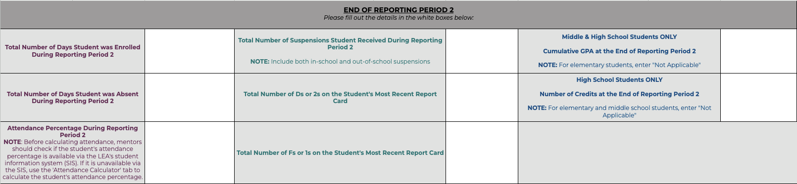

- Reporting Period 1 ends on October 31.
- Reporting Period 2 ends on January 31.

Note: The following fields require period-specific data. Be sure to follow the guidance provided below.

Attendance
- Total Number of Days Student Was Enrolled During the Reporting Period: Enter the total number of days the student was enrolled during the reporting period.
- Total Number of Days Student Was Absent During the Reporting Period: Enter the total number of days the student was absent during the reporting period.
- Attendance Percentage During the Reporting Period: Enter the student’s attendance percentage for the reporting period.
  - Before calculating attendance, mentors should check if the student’s attendance percentage is available via the LEA’s Student Information System (SIS).
  - If needed, you can use the Attendance Calculator tab to calculate the student’s attendance percentage by entering the total number of days the student was enrolled and the total number of days the student was absent.

Behavior
- Total Number of Suspensions Student Received During the Reporting Period: Enter the total number of suspensions the student received during the reporting period.

Course Performance
- Total Number of Ds or 2s on the Student’s Most Recent Report Card: Enter the total number of Ds or 2s a student received as a final course grade based on their most recent report card.
- Total Number of Fs or 1s on the Student’s Most Recent Report Card: Enter the total number of Fs or 1s a student received as a final course grade based on their most recent report card.
- Cumulative GPA at the End of the Reporting Period: For middle and high school students, enter the student’s cumulative GPA at the end of the reporting period, rounded to two decimal places (for example: 3.10, NOT 3.1).
  - For elementary or middle school students attending a school where GPA is not collected, enter “Not Applicable.”
- Number of Credits at the End of the Reporting Period: For high school students, enter the total number of credits the student has earned to date, rounded to one decimal place (for example: 3.6, NOT 4).
  - For elementary and middle school students, enter “Not Applicable.”

Fill in the following fields at the end of Reporting Period 3:

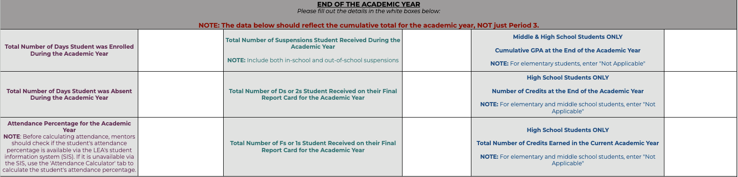

- Reporting Period 3 ends at the end of the academic year.

Note: The following fields require aggregate data for the current academic year. Be sure to follow the guidance provided below.

Attendance
- Total Number of Days Student Was Enrolled During the Academic Year: Enter the total number of days the student was enrolled during the academic year.
- Total Number of Days Student Was Absent During the Academic Year: Enter the total number of days the student was absent during the academic year.
- Attendance Percentage for the Academic Year: Enter the student’s attendance percentage for the academic year.
  - Before calculating attendance, mentors should check if the student’s attendance percentage is available via the LEA’s Student Information System (SIS).
  - If needed, you can use the Attendance Calculator tab to calculate the student’s attendance percentage by entering the total number of days the student was enrolled and the total number of days the student was absent.

Behavior
- Total Number of Suspensions Student Received During the Academic Year: Enter the total number of suspensions the student received during the academic year.

Course Performance
- Total Number of Ds or 2s Student Received on Their Final Report Card for the Academic Year: Enter the total number of Ds or 2s a student received as a final course grade for the academic year.
- Total Number of Fs or 1s Student Received on Their Final Report Card for the Academic Year: Enter the total number of Fs or 1s a student received as a final course grade for the academic year.
- Cumulative GPA at the End of the Academic Year: For middle and high school students, enter the student’s cumulative GPA at the end of the academic year, rounded to two decimal places (for example: 3.10, NOT 3.1).
  - For elementary or middle school students attending a school where GPA is not collected, enter “Not Applicable.”
- Number of Credits at the End of the Academic Year: For high school students, enter the total number of credits the student has earned to date, rounded to one decimal place (for example: 3.6, NOT 4).
  - For elementary and middle school students, enter “Not Applicable.”
- Total Number of Credits Earned in the Academic Year: For high school students, enter the total number of credits the student earned during the current academic year, rounded to one decimal place.
  - For elementary and middle school students, enter “Not Applicable.”

Check & Connect Reporting Form Instructions

Overview
Mentors, mentor coordinators, or directors must complete and submit the Check & Connect Reporting Form (via Google Forms) for each student at the end of every reporting period. Once submitted, the form is automatically received by Amanda Charlesworth, USBE YIC Check & Connect Program Specialist.

At the end of each reporting period, mentor teams should use the data from the Student Details and Summary tabs of the Check & Connect Mentor Weekly Notes to complete one Check & Connect Reporting Form per student.
Important Dates
- Reporting Period 1: Reporting Forms should be submitted by November 15.
- Reporting Period 2: Reporting Forms should be submitted by February 15.
- Reporting Period 3: Reporting Forms should be submitted by June 15.

Filling Out the Check & Connect Reporting Form
- Click the link to the Check & Connect Reporting Form shared by USBE.
- Enter your district email address.
  - Use your district credentials (i.e., your district/work email address, NOT your personal email address).

Use the Student Details tab of the Check & Connect Mentor Weekly Notes to fill in the following information:

- Select the current academic year.
- Select the school district.
- Select the reporting period for which you are submitting student data.
- Enter the student’s State ID Number (SSID).
- Select the student’s grade level.
- Select whether the student has an IEP (Individualized Education Program).
- Select whether the student has a 504 Plan.
- Enter the date the student entered the Check & Connect Program in MM/DD/YYYY format.
- Select whether the student is receiving Check & Connect through Youth-in-Care or Prevention.
- Select the student’s DHHS provider.

When reporting data for Periods 1 and 2, use the Summary tab of the Check & Connect Mentor Weekly Notes to fill in the following information:

- Select the appropriate range for the student’s attendance percentage.
  - Please round up when necessary (for example: If a student’s attendance is 50.5%, select the “51-55%” range).
- Select the number of suspensions a student received.
  - Include both in-school and out-of-school suspensions.
- Select the number of Ds or 2s the student received on their most recent report card.
- Select the number of Fs or 1s the student received on their most recent report card.

For all reporting periods, use the Summary tab of the Check & Connect Mentor Weekly Notes to fill in the following information:

Connect
- The total number of Connect meetings you had with the student during the reporting period.
- The total number of times you shared Check data with the student during the reporting period.
- The total number of times you provided feedback to the student during the reporting period.
- The total number of times you discussed the relevance and importance of staying in school and learning with the student during the reporting period.
- The total number of times you engaged in problem-solving with the student during the reporting period.
- The total number of times you facilitated goal-setting with the student during the reporting period.
- The total number of times you facilitated student access to or active participation in school-related activities and events during the reporting period.

Intervention
- Is the student receiving intensive intervention to support the area(s) where they have been identified as high risk (e.g., attendance, behavior, grades)? Select “Yes” if a student has been identified as high risk and is receiving or has received intensive intervention. Otherwise, select “No.”
  - If a student is not high risk based on the criteria above, select “The student has not been identified as high risk.”
- For students who are receiving or have received intensive intervention, indicate how successful you feel the intervention has been at improving the student’s engagement at school and with learning during the reporting period.
  - The scale ranges from 1 (not successful) to 5 (very successful).
  - This rating is based entirely on the mentor’s perception of intervention success.

Engagement With Student’s Team
- The total number of times you communicated with the student’s classroom teacher(s) or other school staff during the reporting period.
- The total number of times you communicated with the student’s family or placement caregivers during the reporting period.
- The total number of times you communicated with the student’s case worker or case manager during the reporting period.
  - For students who do not have a case worker or case manager, select “Not Applicable.”
- The total number of times you communicated with any other members of the student’s team during the reporting period.
  - For students who do not have any other team members, select “Not Applicable.”

Exit
- Select whether the student has exited the Check & Connect program during that reporting period.

If the student has exited, use the Student Details tab of the Check & Connect Mentor Weekly Notes to fill in the following information:

- Enter the date the student exited the Check & Connect Program in MM/DD/YYYY format.
- Select a reason why the student exited.
  - If none of the listed exit reasons apply, please contact Amanda Charlesworth, USBE YIC Check & Connect Program Specialist.

When reporting data for Period 3, use the Summary tab of the Check & Connect Mentor Weekly Notes to fill in the following information:

- Have you worked with the student for the entire academic year? Select “Yes” if you have been the student’s Check & Connect mentor for the entire academic year. Otherwise, select “No.”
- Select the appropriate range for the student’s attendance percentage for the academic year.
- Select the number of suspensions the student received in the academic year.
- Select the number of Ds or 2s a student received on their final report card for the academic year.
- Select the number of Fs or 1s a student received on their final report card for the academic year.
- For middle and high school students, select the appropriate range for the student’s cumulative GPA for the academic year.
  - For elementary or middle school students attending a school where GPA is not collected, enter “Not Applicable.”
- For high school students, select the appropriate range for the total number of credits a student earned in the current academic year.
  - For elementary and middle school students, enter “Not Applicable.”

Submitting the Check & Connect Reporting Form
- Once you reach the end of the form, click Submit.
- You will receive a confirmation email with a copy of your responses.

If you need to correct an error in your submission:
- Email Amanda Charlesworth, USBE YIC Check & Connect Program Specialist.
- In the email, include the student’s State ID Number (SSID) and the date you submitted the data.
- Resubmit the student’s data using the Check & Connect Reporting Form.

Submit data for each additional student on your caseload using the Check & Connect Reporting Form link shared by USBE.

Glossary
Absenteeism
A full day’s absence for excused or unexcused reasons, including days missed due to out-of-school suspension.

Attendance Percentage
The percentage of days a student was present during the reporting period or academic year. Calculated by dividing the number of days present by the total number of enrolled days, then multiplying by 100.

Classes Missed
The number of class periods missed within a school day.

High Risk
A student is considered high risk if they meet any of the following criteria:
- 2 or more Ds (or 2s) or 1 or more Fs (or 1s)
- An attendance percentage <90%
- 2 or more behavioral incidents
In-School Suspension
A consequence for inappropriate behavior where the student spends the school day(s) in a separate area or classroom. The student is typically supervised or required to participate in a structured activity.
Out-of-School Suspension
A consequence for certain behaviors where the student spends a specified number of school days at home. The student is not permitted on school property during this period.
State Student ID Number
A unique number assigned to each student in Utah public schools. It can be found on the Youth in Care – Student Information Form or in the district’s Student Information System (SIS). Mentors should work with their directors to gain access if needed.
Total Number of Credits Earned in the Academic Year
Calculated by subtracting the number of credits a student had at the start of the school year from the number of credits a student has at the end of the school year.

FAQ
- Do I need to create a Check & Connect Mentor Weekly Notes spreadsheet for each student?
Yes. You must create a separate Mentor Weekly Notes spreadsheet for each student on your caseload.
- How do I calculate a student’s attendance?
A student’s attendance percentage is typically available through your district’s Student Information System (SIS). This should be your primary source for attendance data.
If the attendance percentage is not available via the SIS, use the “Attendance Calculator” tab in the Mentor Weekly Notes spreadsheet.
- What do I do if a student exits Check & Connect before the end of the reporting period?
If a student exits your caseload before the end of the reporting period:
- Record the exit date and reason on the “Student Details” tab in their Mentor Weekly Notes spreadsheet.
- You are still required to complete the Check & Connect Reporting Form for that student at the end of the reporting period.

- Am I done with my end-of-period reporting when I complete the Check & Connect Mentor Weekly Notes spreadsheet?
No. In addition to completing the Mentor Weekly Notes, you must complete and submit the Check & Connect Reporting Form using the link provided by USBE at the end of each reporting period.
- Where can I find the link to the Check & Connect Reporting Form?
USBE will provide the link to the Reporting Form at the end of each reporting period.
- Do I need to submit a Check & Connect Reporting Form for each student?
Yes. You must submit a Check & Connect Reporting Form for every student on your caseload, including any who exited before the end of the reporting period.
- What should I do if I make an error in my Check & Connect Reporting Form?
Always review your form carefully before submitting.
If you notice an error after submission:
- Email Amanda Charlesworth, USBE YIC Check & Connect Program Specialist.
- In your email, include:
  - The student’s State ID Number (SSID).
  - The date you submitted the form.
  - A note that you will be resubmitting the correct form.
- Resubmit a Reporting Form for the student.

- What are the dates for the different reporting periods?
- Reporting Period 1 begins on the first day of the academic year and ends on October 31.
- Reporting Period 2 begins on November 1 and ends on January 31.
- Reporting Period 3 begins on February 1 and ends on the last day of the academic year.

- When are the Reporting Forms due?
- Reporting Forms for Period 1 should be submitted by November 15.
- Reporting Forms for Period 2 should be submitted by February 15.
- Reporting Forms for Period 3 should be submitted by June 15.

